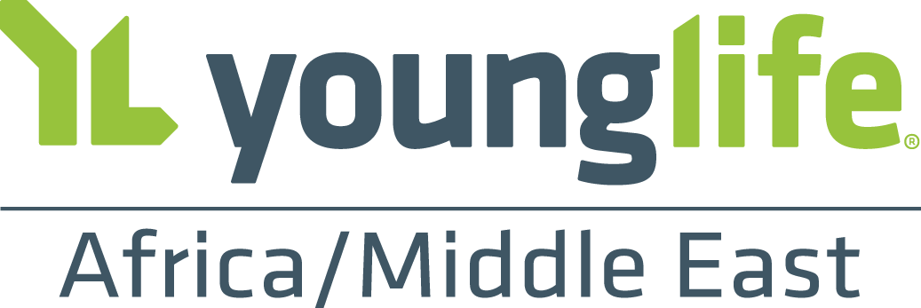

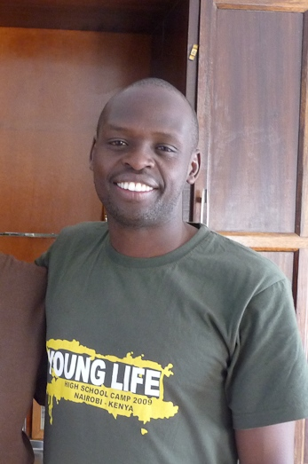
David Lemiso

David Lemiso is an Area Director in Kilgoris, Kenya, in the southwestern part of the country. He is also the Executive Director of The Kilgoris Project (TKP), which operates 7 preschool and primary schools for 1,000 students as well as a self-sustaining tree farm to raise in-country revenue. While a focus of David’s time is on younger children, he saw a need to reach teenagers in his community for Christ so a partnership was forged between TKP and Young Life, which has allowed YL ministry to grow and flourish under David’s leadership in this Maasai region of Kenya.

